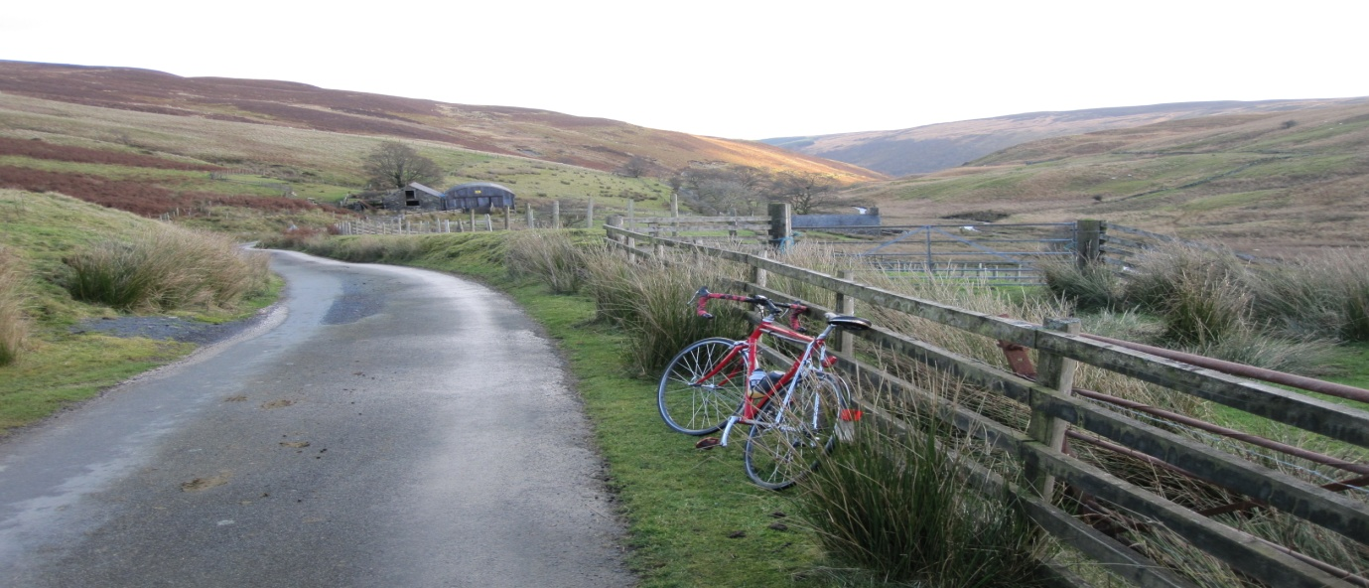

These well established, classic rides are based on Duddon Community Hall near Tarporley, Chester CW6 0EZ and visit the beautiful Berwyn hills above Llangollen.
"Tour of the Berwyns" 200k. The West Cheshire/ N. Wales classic audax ride which has been followed for at least 30 years with just a few variations. Once out of Cheshire, the route visits the beautiful Panorama road above the Llangollen. After descending the Panorama, the River Dee is then followed to Corwen along the Old Coach Road. From here the central, key section climbs the Milltir Gerrig pass, descends to Llangynog and then follows the hill road from Llanrheadr-Y-M back over the hills to Chirk. Finally there is a flat run back through Cheshire lanes to Duddon. An exhilarating ride in outstanding scenery.
" Panorama Prospect" 130k A shorter version of the above, which misses the key, mountain section of the 200k route by descending early from the Panorama to the Aqueduct and hence Chirk. A similar finish to the Tour of the Berwyns is then followed through the Cheshire lanes.
Full details of these good value rides, low cost entry, entry forms, route sheets, gpx etc are available in the calendar section at aukweb.net. There is also a lot of information here for newer riders in the FAQ section.
Plenty of free car parking at the start/finish.
Entries on-line using paypal or by snailmail now available until closing date 30 May 2022.

